**INTERNSHIP REPORT**

**ON**

**COVID-19 MANAGEMENT SYSTEM**

**BY**

**S. Nithin Nithish N Shetty**

**4JK19CS404 4JK19CS403**

**ShivaShankar B N**

**4JK19CS405**

**IN THE DOMAIN**

**OF**

**WEB DEVELOPMENT**

**Company Profile**

e-Brain Softech Pvt. Ltd. Is a leading software development firm and training body, has been

operational in Karnataka with a dedicated panel of experts from IT Industry. They provide

services on Management, Education technology and guidance to anyone looking on any areas

of interest. They are a team of qualified, experienced trainers and IT Professionals motivated

to educate people by training and nurturing them to the best of their strengths.

e-Brain develop Websites, Apps, Interfaces, AI, IoT Products and more. They are a fullservice

product strategy, design, and development partner. Focusing on the customer, they design customer’s journey, optimizing every touchpoint for convenience and delight. The products of e-Brain : Digital Eye, A.I Based Spot Attendance System, OnlineX, Unified Services, EduBrain.

**About Domain**

Web development can essentially be characterized as the structure and support of sites for facilitating by means of web or intranet. Making web pages that run in the internet browser which includes learning a few programming dialects, systems, databases so on as various sites and applications utilize various advancements and have various functionalities.

As different websites and apps use different technologies. It’s all about creating web pages (websites) or application (such as Amazon or Facebook) that run in a web browser. Web improvement is extensively grouped into front-end and back-end development. Front-end development is client-side, the face of the web page that the user interacts with.

Front-end developers are accountable for a website user-facing code and design the immersive user experiences. In order to those intentions, frontend developers must be skilful in three main languages. Primary programming knowledge needed is HTML, CSS and Java Script. Back-end development is server side, the computational logic behind a website or an app. The core responsibilities of backend development are, sending contact form, editing page content, and signing from newsletter. The backend comprises of a server, an application, and a database. The backend developer shapes and maintains the technology that powerhouse those components. It enables the user-facing side of a website to even be in the first place. Therefore, backend developer receives and front end implements. Primary programming knowledge needed is Python, .NET, Java and PHP.

**Learning Outcomes:**

In the beginning of our internship we learnt about the overview of the web development where there are many basic terminologies like node, network, client, server and more. After that we learnt basic Linux commands, then few frontends and backend languages as follow:

1. HTML

2. CSS

3. Bootstrap

4. PHP

1. HTML:

• HTML stands for Hyper Text Markup Language.

• HTML is the standard markup language for creating Web pages.

• HTML describes the structure of a Web page.

• HTML consists of a series of elements.

• HTML elements tell the browser how to display the content.

• HTML elements label pieces of content such as "this is a heading", "this is a paragraph", "this is a link", etc.

2. CSS:

• CSS stands for Cascading Style Sheets.

• CSS describes how HTML elements are to be displayed on screen, paper, or in other media.

• CSS saves a lot of work. It can control the layout of multiple web pages all at once.

• External style - sheets are stored in CSS files.

3. Bootstrap:

• Bootstrap is a free open – source front-end framework for faster and easier web development.

• Bootstrap includes HTML and CSS based design templates for typography, forms, buttons, tables, navigation, modals, image carousels and many other, as well as optional JavaScript plugins.

• Bootstrap also gives you the ability to easily create responsive designs.

4. PHP:

• PHP is an acronym for "PHP: Hypertext Preprocessor".

• PHP is a widely-used, open source scripting language.

• PHP scripts are executed on the server.

• PHP is free to download and use.

And also, we learnt about database. The term **‘database’** is defined as any collection of electronic records that can be processed to produce useful information. The data can be accessed, modified, managed, controlled and organized to perform various data-processing operations. We used Structured Query Language (SQL) to manage the database.

**ABSTRACT**

Covid-19 management systems belong to the class of application software intended for storage and management of information obtained in the course of the work of the laboratory. The systems are used to control and manage samples, standards, test results, reports, laboratory staff, instruments, and work flow automation. Integration of laboratory information management systems with the enterprise’s information systems will make it possible to promptly transmit required data to the laboratory and the enterprise administration. Key words information measurement systems–information management systems–laboratory information management systems–functionality of management system

**Roles assigned to the different team members**

|  |  |
| --- | --- |
| **Team Member** | **Role Assigned** |
| S Nithin | Frontend and Backend  1. Home Page  2. Admin Page  3. Backend Working |
| Shivashankar B N | Frontend and Backend  1. Testing Page  2. Database Queries |
| Nithish N Shetty | Frontend and Backend  1. Live updates Page  2. Database Design |

**REQUIREMENT ANALYSIS**

• **Software Requirements:** Sublime Text, XAMPP Server, Browser.

• **Hardware Requirements:** Windows 7 or higher, 512MB of RAM, 100MB Storage Space, basic input and output devices.

**PAGE LAYOUTS**

1.Landing Page

|  |
| --- |
| About us Covid-19 Symptoms Prevention Testing Live Update AdminAbout usCovid-19 SymptomsPrevention Copyright |

2.Testing Page

Full Name:

Mobile Number:

DOB:

Any Govt Issued ID:

Govt Issued ID Number:

Address:

State:

Test Type:

Time Slot for Test:

**Submit**

3.Live Update or DashBoard Page

**State wise Testing Dashboard:**

|  |  |  |
| --- | --- | --- |
| **Sno.** | **State Name** | **Total Test Done** |

4. Admin Page

**Covid Testing Management System**

**Welcome Back**

Enter username:

Enter password:

Forget password?

Home page

**Login**

5. Test Report Page

**Search Report**

**Search by Patient Name or Mobile Number or Order Number**

Enter name or mobile number or Order Number

**Search**

**FLOW CHART**

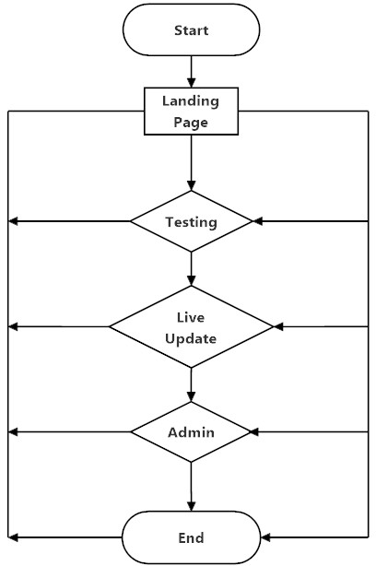

**DATA FLOW DIAGRAMS**

**DATA FLOW DIAGRAM FOR ADMIN LOGIN**

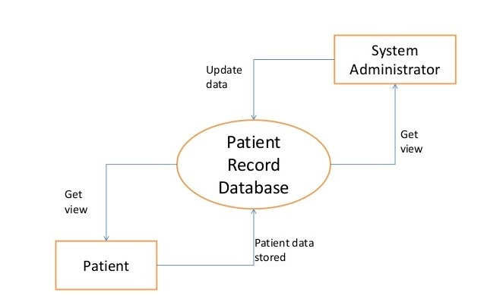

**DATA FLOW DIAGRAM FOR USER**

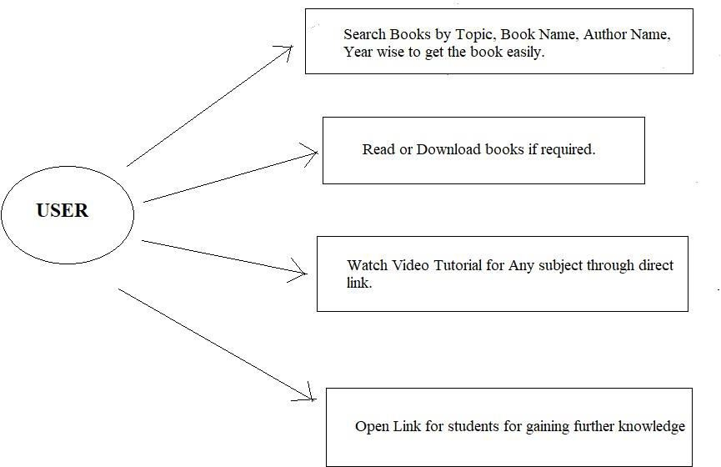

PSEUDO CODE

**Index Page:**

1. Nav-bar.

2. Paragraph with information.

3. Footer.

**Testing Page:**

1. Nav-bar.

2. Form for the user register.

3. Buttons to submit form.

4. Tesxt box and button for searching.

**Live updates Page:**

1. Nav-bar.

2. Table with the tested infromations.

**Admin Login Page:**

1. Nav-bar.

2. Form for the admin username and password.

3. Button to submit.

**Admin Home Page:**

1. Nav-bar.

2. Table with the user infromations.

**Backend:**

**Testing Page:**

1. Get the information from the front-end form.

2. Insert the information into the database.

3. Return the ID of the insertion.

**Live Update page:**

1. Return the values from the query result.

**Admin Home Page:**

1. Query the database.

2. Update the table in the front-end.

**SCREENSHOTS**

* 1. **Screenshot for homepage**

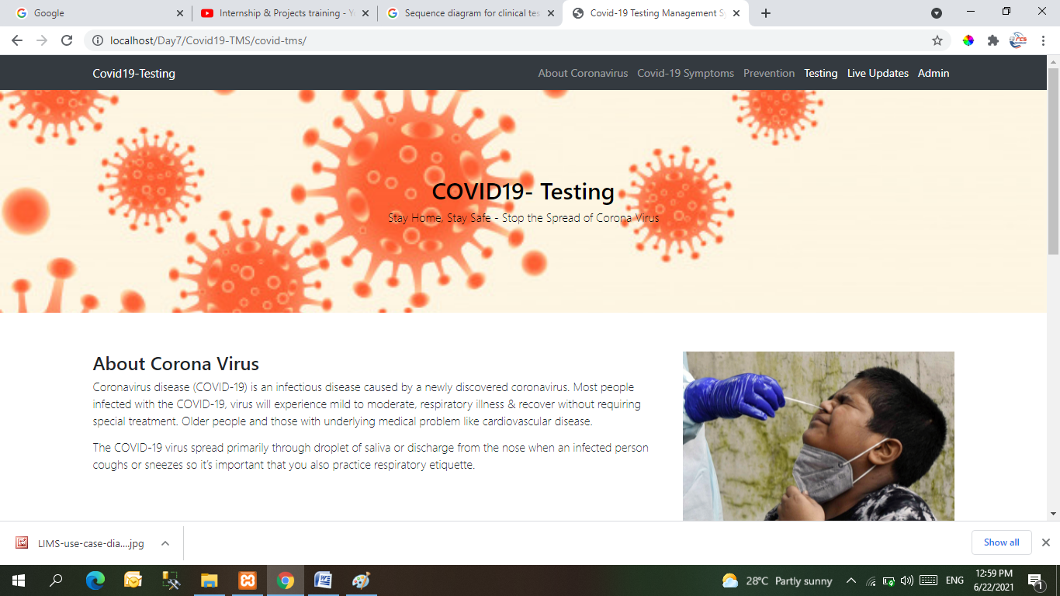

**Screenshot of user.**

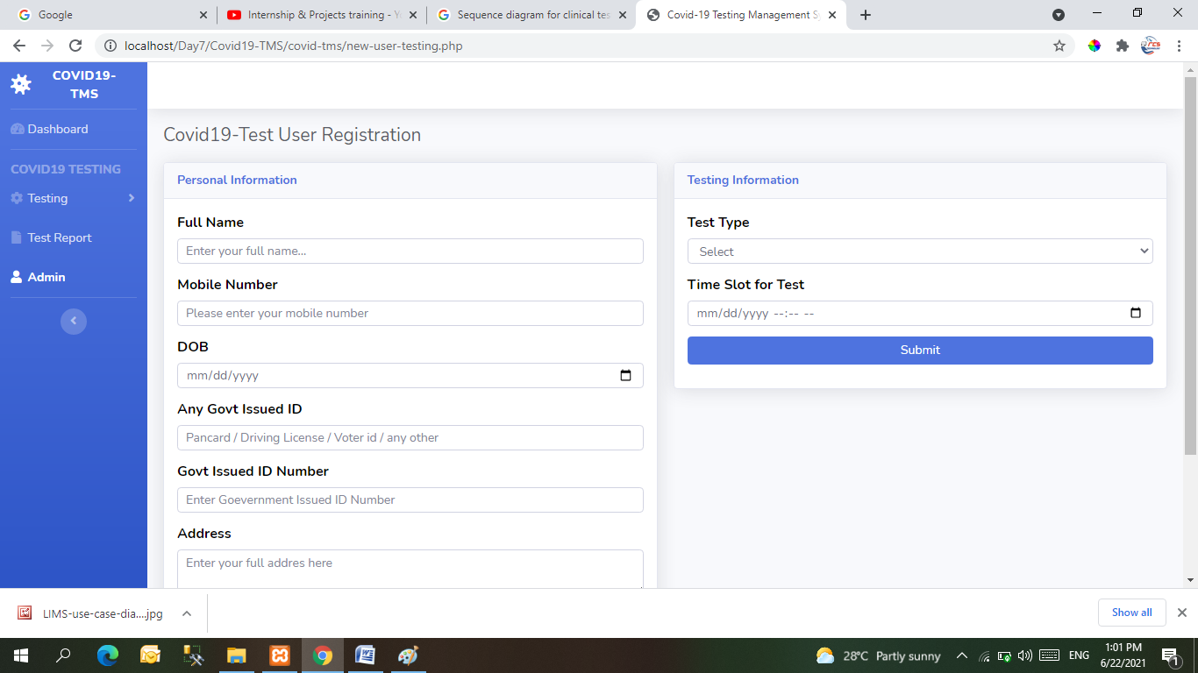

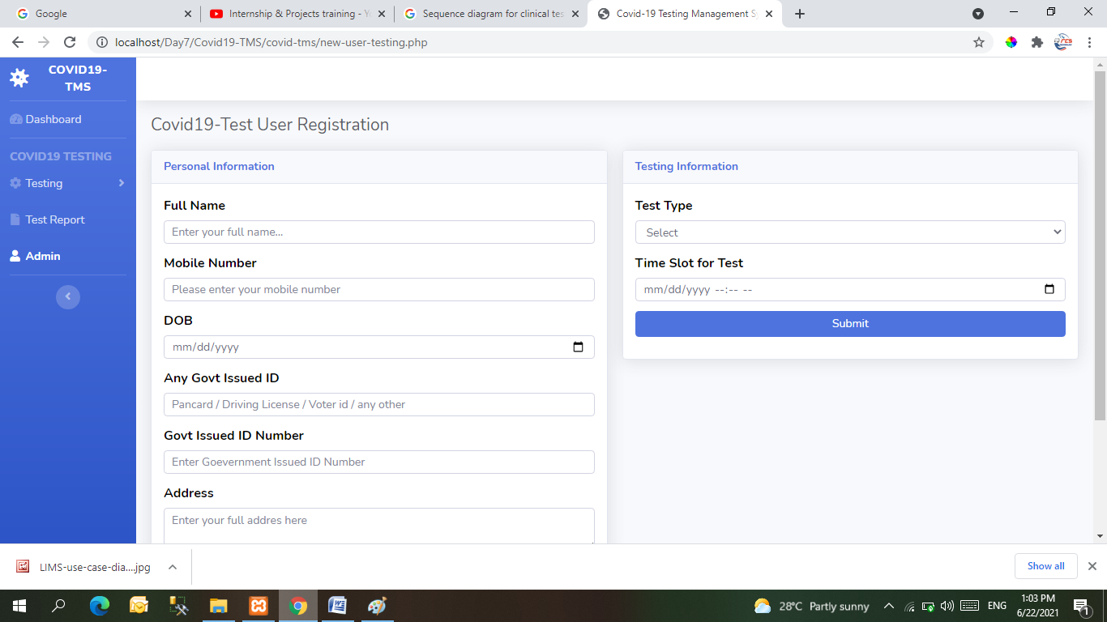

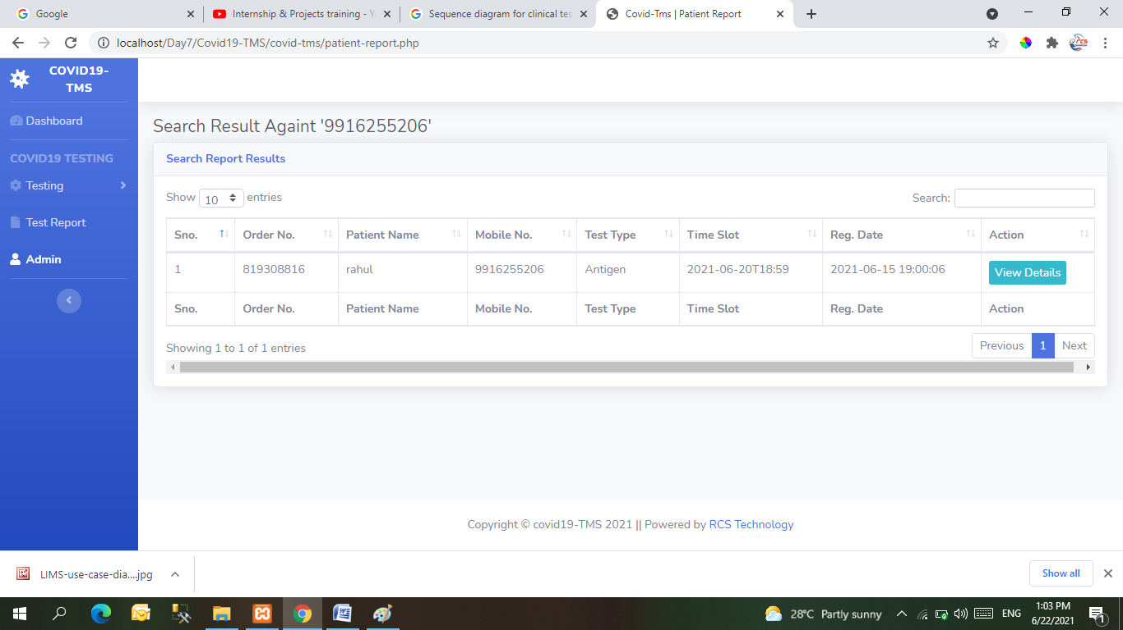

**Screenshot of videos from user**

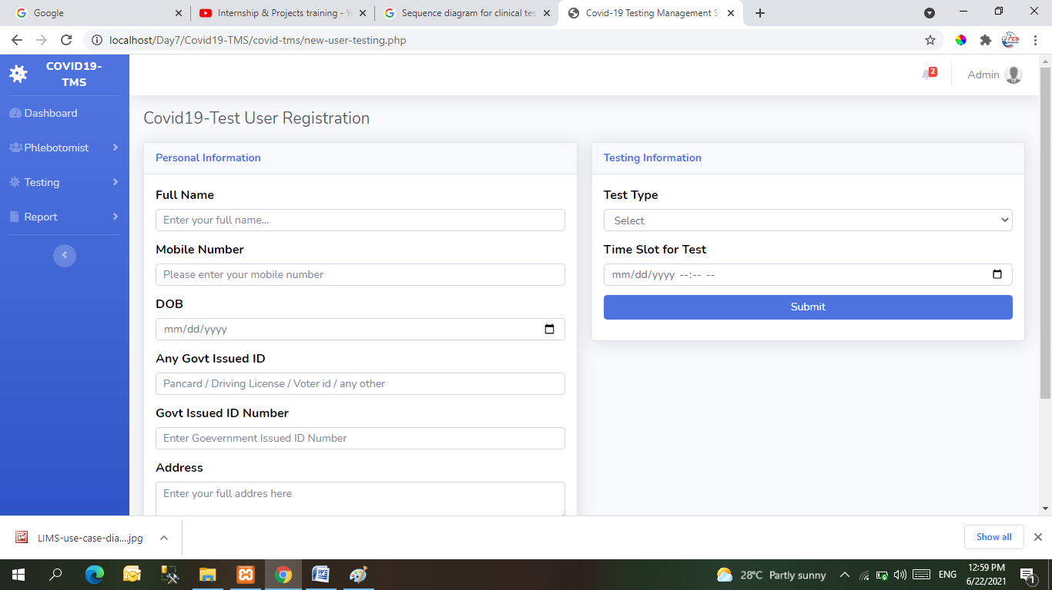

# **Admin Login**

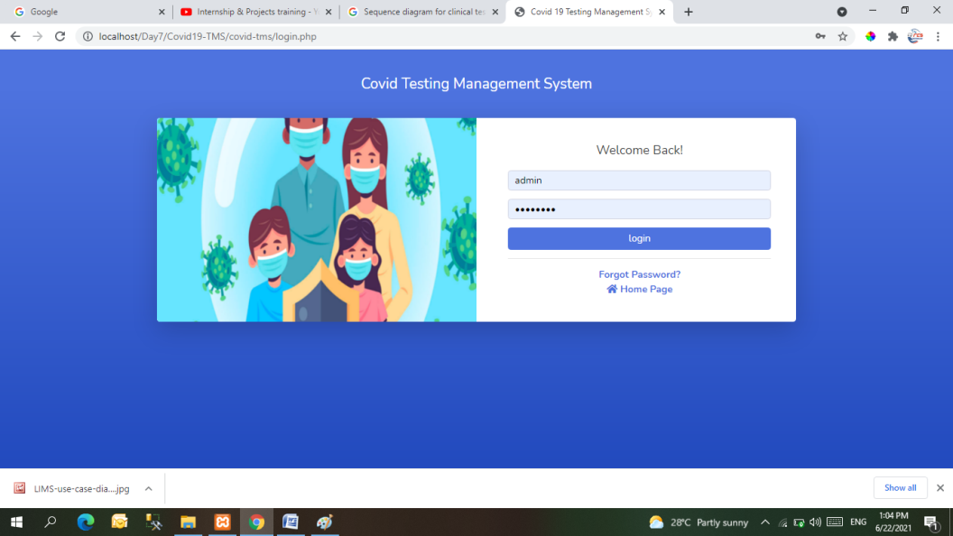

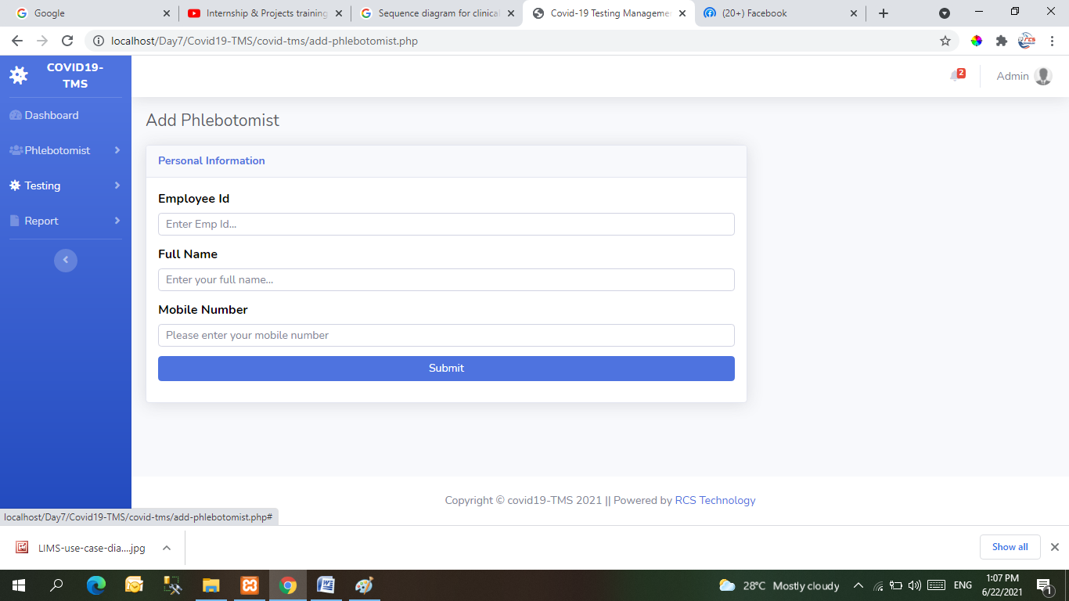

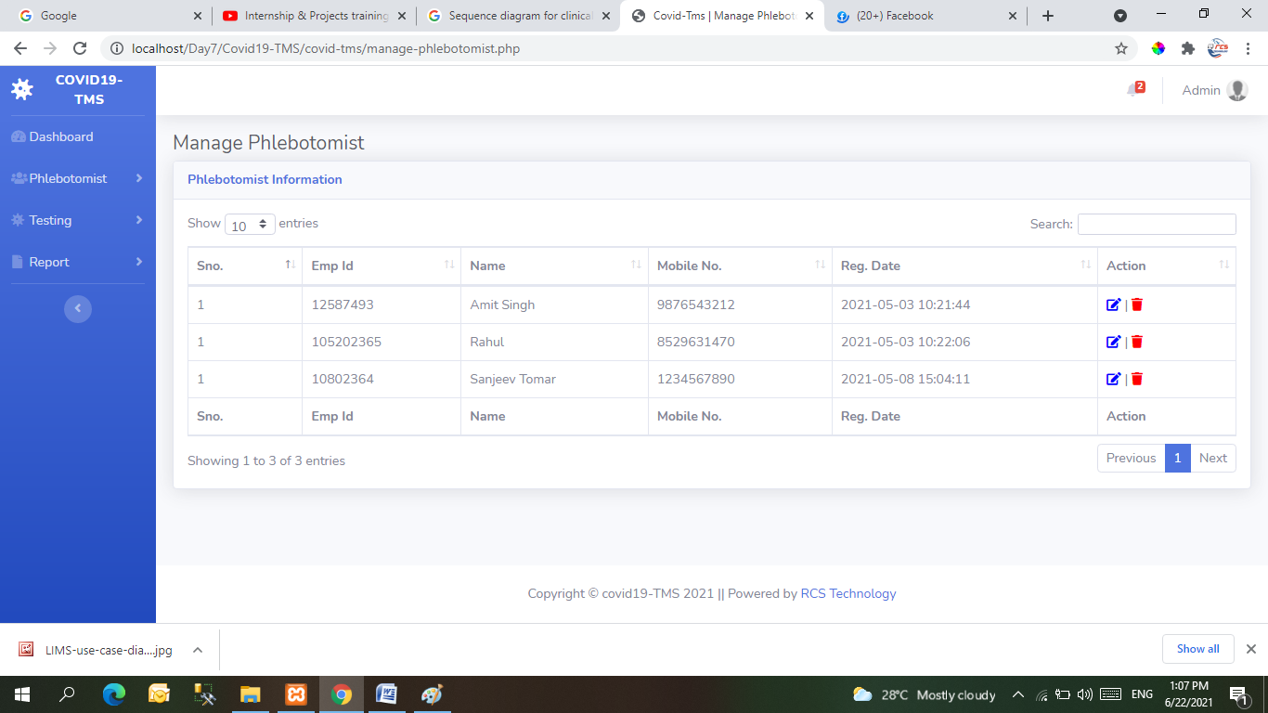

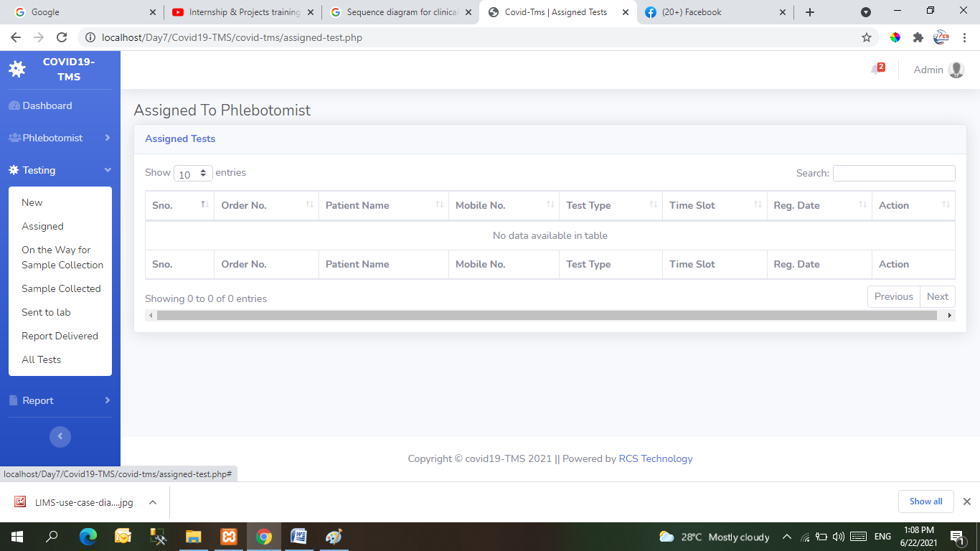

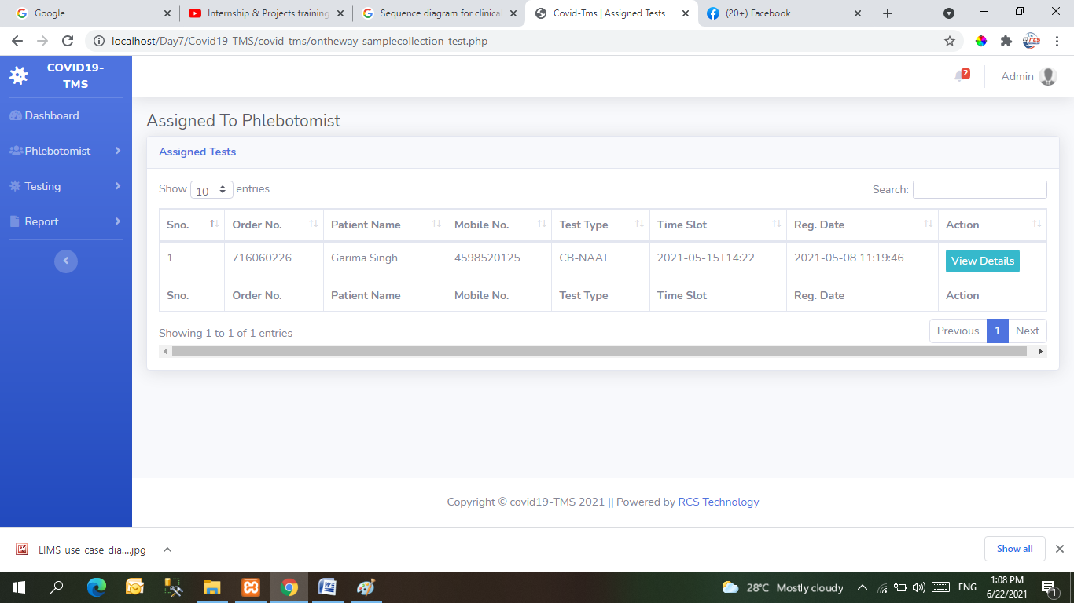



CONCLUSION & FUTURE SCOPE

This website provides a computerized version of Covid-19 Test system which will benefit the patients as well as the staff of the Departments

It makes entire process online where patients can search Register,schedule Test,Track Reord, staff can generate reports and do Test transactions. It also has a facility for patients to see status of Test issued as well request for Report or give some suggestions.

REFERENCES

* http://www.w3schools.com/html/html_intro.asp
* <http://www.Udemy.com/css/css_background.asp>
* http://www.w3schools.com/js/js_datatypes.asp